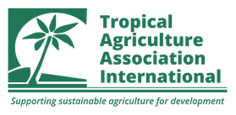
The Development and Use of Biological Agents and Extracts in Tropical Agricultural Systems.
11.00 Tuesday 4th November to 15.30 on Wednesday 5th November 2025
at Rothamsted Research, UK.

Poster Registration
Title: | Name:
Email: | Mobile:
Position and Organisation:

Title of Poster:

Abstract of Poster:

150 words Max
Short Biography:

150 words Max
Note: Details above will be used in publicity and the programme for the Conference

Consent Form:
Yes /No
Poster being made available in the TAAI Ag4Dev Journal.
Photos from the Conference being used by TAAI.
Confirmation:
Yes /No
A4 pdf of the poster to be sent by email to gen_sec@taa-internaional.org by Thursday 30th October.
A0 version of the poster being sent direct to Rothamsted c/o Krista Friis to arrive by Thursday 30th October.
A0 version of the poster being carried to Rothamsted for arrival by 10 am on Tuesday 4th November.
TAAI to print an A3 copy of the poster for display

Signed……………………………………… Date……………………………….

